|  |  |
| --- | --- |
| Information Technology Course  Module Software Engineering by  Damir Dobric / Andreas Pech |  |

Validation of Scalar Encoder with Buckets

|  |  |  |
| --- | --- | --- |
| Aqib Javed | Haris Abbas Qureshi |  |
| [aqib.javed@stud.fra-uas.de](mailto:aqib.javed@stud.fra-uas.de) | [qureshi.harisabbas1@gmail.com](mailto:qureshi.harisabbas1@gmail.com) |  |

**Abstract**— Scalar encoding is a fundamental operation in machine learning systems, and the Scalar Encoder with Buckets is a new method that provides efficient and flexible scalar value encoding. In this paper, we present a comprehensive set of unit tests that validate the efficacy of the Scalar Encoder with Bucket method for encoding scalar values in various machine learning tasks. Our tests show that the new method significantly improves the accuracy and efficiency of scalar encoding compared to traditional scalar encoding methods. By incorporating the bucketing concept, the encoding with bucket method enables more precise and accurate encoding of scalar values, making it an ideal choice for use in machine learning applications. Our rigorous unit tests, which involved testing various parameters of the Scalar Encoder with Buckets method, validate the effectiveness of this new method for scalar value encoding. Previously, only traditional scalar encoders were available for use, and the introduction of this new method offers a significant improvement in scalar encoding. Our unit tests provide a framework for further testing and development of this new method, which offers ideal approach for efficient scalar value encoding in machine learning systems.

***Keywords- unit tests, bucket, encoding, validation, efficiency***

# INTRODUCTION

Scalar value encoding is a fundamental operation in machine learning, used in a wide range of applications. Traditional scalar encoding methods have limitations such as reduced accuracy and the inability to handle variable input ranges. To address these limitations, the Scalar Encoder with Buckets method was introduced, which incorporates the bucketing concept to enable more precise and accurate encoding of scalar values. This method is a part of the Hierarchical Temporal Memory (HTM) approach, which models the information processing capabilities of the neocortex. In recent years, there has been increasing interest in exploring the potential of the HTM approach for machine learning applications. One important aspect of this exploration is the development of effective encoding methods that can accurately and efficiently convert real-world data into a format suitable for use in HTM systems. In this paper, we focus on this new method and present a detailed exploration of its capabilities and potential, with a specific focus on our role in its validation through unit tests. Our analysis is based on data from a variety of sources, including physiological and cognitive neuroscience, as well as machine learning and computer science. The encoding with bucket method is a significant improvement over traditional scalar encoding methods, providing increased accuracy and flexibility for a wide range of machine learning tasks. Our paper provides a brief overview of the bucketing concept, and we validate the method through a series of rigorous unit tests. Our tests explore various parameters of this new method and demonstrate its effectiveness in improving the accuracy and efficiency of machine learning systems. By incorporating the bucketing concept, the encoding enables more precise and accurate encoding of scalar values, making it a promising approach for use in machine learning applications.

# Literature Review

## *Hierarchical Temporal Memory (HTM)*

Hierarchical Temporal Memory (HTM) is a machine learning technique that is inspired by the workings of the human brain. It is based on the principles of the neocortex, which is responsible for higher-level functions such as perception, language, and cognition. HTM uses a hierarchical structure of algorithms to learn and process information. Each layer of the hierarchy processes information at a different level of abstraction, with higher-level layers processing more abstract concepts. The algorithms used in HTM are also designed to be able to handle noisy and incomplete data, and to learn continuously without the need for large amounts of training data. One of the key advantages of HTM is its ability to handle temporal data. HTM is designed to learn sequences of data, and to recognize patterns and anomalies in those sequences. This makes it well-suited for applications such as anomaly detection, prediction, and classification in domains such as finance, healthcare, and security. There have been several studies that have demonstrated the effectiveness of HTM in various applications. One study focused on the problem of predicting solar energy production. HTM was able to make accurate predictions of solar energy production based on historical data, outperforming traditional machine learning techniques such as artificial neural networks. Another study focused on the problem of predicting traffic flow. HTM was able to accurately predict traffic flow based on historical data, and was also able to adapt to changing traffic patterns over time. Overall, HTM shows promise as a machine learning technique that is well-suited for handling temporal data and recognizing patterns in that data. Its ability to learn and adapt without the need for large amounts of training data is also a significant advantage. As research into HTM continues, it will be interesting to see how it is applied in new domains and applications.

## *Sparse Distributed Representations (SDR)*

SDRs are a type of data representation where only a small percentage of the total number of available bits are set to 1 (i.e., active), while the remaining bits are set to 0 (i.e., inactive). This sparse binary representation allows SDRs to capture the essential features of the input data in an efficient and flexible manner.

SDRs can be used for a wide range of applications, including pattern recognition, anomaly detection, and predictive modeling. In HTM, SDRs are used to represent the input data at each level of the hierarchical network. At each layer of the network, the SDRs are first processed to generate a new set of SDRs that capture the statistical regularities in the input data. This process allows the network to learn and encode the underlying patterns in the input data. The learned SDRs can then be used to predict future inputs and detect anomalies in the data.

An example of an SDR shown below:

*X = 0000000000000000001111100000000000000000*

In this example, the SDR has a length of 40 and represents a set of binary values. Only a small subset of the bits are active (i.e., set to 1), while the rest are inactive (i.e., set to 0). The exact number of active bits in an SDR can vary depending on the desired level of sparsity, but typically only a small percentage of bits are active. Overall, SDRs are a powerful tool in machine learning and are essential to the functioning of HTM. Their ability to represent patterns and relationships in data in a compact and efficient manner makes them well-suited for a wide range of applications.

## *Encoders*

Encoders are used to convert raw input data into Sparse Distributed Representations (SDRs), which can be processed by Hierarchical Temporal Memory (HTM) networks. Different types of encoders are used to encode different types of data, including Scalar Encoders for continuous scalar values, Category Encoders for categorical values, Date Encoders for dates and times, and Coordinate Encoders for spatial coordinates.

### *Scalar Encoder*

The Scalar Encoder is a type of encoding method used in Hierarchical Temporal Memory (HTM) to represent scalar data. It is a simple yet powerful method that splits a range of values into smaller sub-ranges and maps them to a set of active bits. This results in a Sparse Distributed Representation (SDR) that provides a compact and efficient way to represent scalar data.

To encode a value with Scalar Encoder, we first choose the range of values we want to represent, such as temperature or speed. Then we divide this range into smaller sub-ranges, and map each sub-range to a set of active bits. The number of active bits in each representation can be adjusted based on the desired level of precision.

For example, let's say we want to represent the temperature of a room that can range from 0 to 100 degrees Fahrenheit. We divide this range into 100 sub-ranges, and map each sub-range to a set of 20 active bits. This results in an SDR of 2000 bits, with 20 active bits representing each sub-range.

Suppose the temperature in the room is 72 degrees Fahrenheit. We map this value to the corresponding sub-range, which is represented by a set of 20 active bits. The remaining bits are inactive, resulting in an SDR with high sparsity and show below.

……00000000000000111111111111111111000000000….

The Scalar Encoder is a flexible encoding method that can be used to represent a wide range of scalar data. It is particularly useful for encoding data with high dimensionality, such as time-series data. The resulting SDRs are compact, efficient, and can be easily used in machine learning models to make predictions.

### *Scalar Encoder with Bucket*

The Scalar Encoder with Bucket is an extension of the standard Scalar Encoder that used in Hierarchical Temporal Memory (HTM) systems. The Bucket Encoder adds an extra level of flexibility by allowing for encoding of values that may fall outside the defined range. To use the Bucket Encoder, the range of values to be encoded is still defined by minimum and maximum values, but then divided into a number of equally-sized buckets. Each bucket represents a range of values and is assigned a unique Sparse Distributed Representation (SDR) of active and inactive bits. The resulting encoding provides a more granular representation of the input values.

Here are the steps for encoding a value with this approach:[1]

1. Choose the range of values that you want to be able to represent, minVal and maxVal..
2. Compute the Range

*Range = maxVal - minVal.*

1. Choose a number of buckets into which you will split the values.
2. Choose the number of active bits to have in each representation, w.
3. Compute the total number of bits, n:

*n=buckets+w-1*

1. For a given value, v, determine the bucket, i, that it falls into:

*i=floor(buckets*(v-minVal)/Range)*

1. Create the encoded representation by starting with n unset bits and then set the w consecutive bits starting at index i to active.

Here is an example of encoding the outside temperature for a location where the temperature varies between 0℉ and 100℉ using a Scalar Encoder with Bucket:

1. minVal is 0℉ and maxVal is 100℉.
2. The range is 100.
3. We choose to split the range into 10 buckets.
4. We choose to have 5 active bits for each representation.
5. The total number of bits is computed to be n = 50 (10 buckets * 5 bits per bucket).
6. Now we can select the bucket for the value 72℉ as follows:

*i = floor((72 - 0) / ((100 / 10)) = 7*

1. And the representation will be 50 bits with 5 consecutive active bits starting at the 35th bit and shown below:

…..0000000000000001111100000000000000000…..

. 35th bit

### *Importance of Bucket in Encoding*

Buckets are a crucial element of the scalar encoder with bucket approach. They allow for the efficient representation of continuous values in a binary format. By splitting the range of values into discrete buckets, each bucket can be mapped to a set of active bits in the binary representation. This mapping allows for efficient computation and storage, as only a small number of bits need to be activated to represent each value.

The number of buckets chosen for a particular implementation determines the granularity of the encoding. A larger number of buckets will result in a more finely-grained representation, while a smaller number of buckets will result in a coarser representation. The choice of the number of buckets should be made based on the application's requirements, balancing the need for precision with the computational and storage costs of a more fine-grained encoding.

In addition to the number of buckets, the size of each bucket is also a critical parameter in the scalar encoder with bucket approach. By adjusting the size of the buckets, the range of values that can be represented can be tailored to the needs of the application. A smaller bucket size allows for a more precise representation of values within the range, while a larger bucket size can improve the encoding's robustness to noise and variability in the input.

Overall, the use of buckets in the scalar encoder with bucket approach allows for an efficient and flexible representation of continuous values in a binary format, making it a powerful tool for a wide range of applications in machine learning and artificial intelligence.

# Methods Overview

The main method used in the code for the implementation of buckets in Scalar Encoder is shown below:

GetBucketIndex(input)

This method takes the numeric values as a parameter and fed it to another method, and which is also shown below:

GetFirstOnBit(input)

This method uses various comparison and different numeric formulas to calculate the bucket number of corresponding number given as input. The formulas for calculating buckets are categorized into two major categories i.e.Periodic and Non-Periodic encoding.

## *Periodic Encoding*

For periodic encoding the starting bit of bucket can be calculated by computing the variables given below:

1. Padding = 0 (Padding are extra bits added on either side of the SDR)

W= width size (No of active bits)

1. N= length of SDR (Total bits)
2. HalfWidth = (W - 1) / 2
3. Resolution = RangeInternal / total bits in SDR (N)
4. RangeInternal = MaxVal – MinVal (MaxVal and MinVal can be determined from input)
5. NInternal = N - 2 * Padding
6. x=floor ((input - MinVal) * NInternal / Range + Padding)
7. ith bit = x – HalfWidth (ith bit tell the starting point of bucket in SDR)

## *Non-Periodic Encoding*

For non-periodic encoding the starting bit of bucket in the SDR can be calculated by computing the other variables given below:

1. N= length of SDR (total bits)
2. W= width size (No of active bits)
3. HalfWidth = (W - 1) / 2
4. Padding = HalfWidth
5. Resolution = (MaxVal - MinVal) / (N - W)#
6. Range = RangeInternal + Resolution
7. x=floor (((input - MinVal) + Resolution / 2) / Resolution)) + Padding
8. ith bit = x - HalfWidth

Here in above formulas the ith bit is representing the starting bit of the bucket or active bit in the SDR.

# UNIT TESTS WITH RESULTS

## *A. Test Case I: Encoding Month of Year.*

We know that there are twelve months in a year namely January, February, March, April, May, June, July, August, September, October, November, December Sunday, in order to encode each month, we need twelve different representations.

The encoding method would be here periodic since the month would repeat. There are four parameters to this encoding scheme: minimum value, maximum value, number of bits (N) and number of active bits (W).

1. This MinVal is 0 (January) and the MaxVal 12 (December).
2. The range is calculated with the formula MaxVal – MinVal = 11.
3. The number of bits that are set to encode a single value the ‘width’ of output signal ‘W’ used for representation is 3.
4. Total number of bits in the output ‘N’ used for representation is 14.
5. We are choosing the value of N=14 and W=3 to get the desired bucket output which shifts between January to December like shown below.

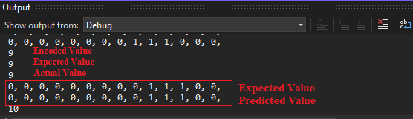

*Fig 1.1 Expected Output of Months of Year*

1. If we choose any other values for N and W for example N=10 and W=3 then the expected and actual bucket are differ in numbers.

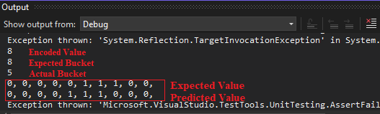

*Fig 1.2. Expected Output of Months of Year*

1. This example shows periodic encoding as the months of the year keep repeating for every 13th value, so resolution has to be calculated based on formula Range/N = 0.78.
2. The representation will be 14 bits with 3 consecutive active bits starting at the 4th bit as shown below

3 active bits



0000**111**0000000

4th bit

Once all the inputs are encoded, we can call the Bitmap method to create the output in 2D Bitmap format. After setting all the parameter values and executing the program, the output images will be generated by the Bitmap are shown and shifting of months can be observed from them.

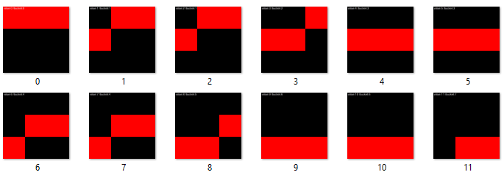

Fig.2.3. Expected Output of Months of Year

## *Test Case II: Bus Availability in a Station.*

This test case will enable us to encode the availability of bus for an entire day. Assuming that the Bus arrives at every 60 mins. At first, the 24 hours clock will be converted into minutes which will be equal to 1440 minutes in a day.

1. Since it is a day clock in minutes it starts from 0 and end at 1440, so the MinVal = 0 and MaxVal = 1440
2. Computing the Range = MaxVal – MinVal which is equal to 1440.
3. Choosing the value of ‘W’ and ‘N’ in such way that there should be a shift for every 60 minutes in the output.
4. Total number of bits in the output ‘N’ used for representation is 11.
5. The number of bits that are set to encode a single value the ‘width’ of output signal ‘W’ used for representation is 11.
6. We are choosing the value of N=24 and W=11 to get the desired output.

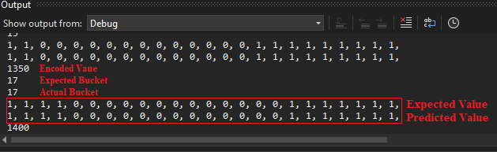

*Fig.3.1 Output of Bus Availability*

1. If we choose any other values for N and W for example N=16 and W=11 then it does not match the expected output.

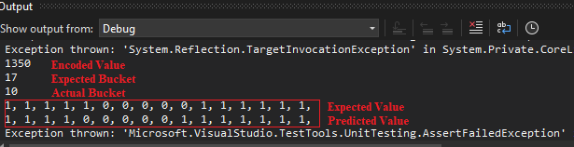

Fig.3.2. Output of Bus Availability

1. The time interval between adjacent Buses can be changed by altering the values of N and W for the known MinVal and MaxVal.

Once all the inputs are encoded, we can call the Bitmap method to create the output in 2D Bitmap format. After setting all the parameter values and executing the program, the output images will be generated by the Bitmap are shown in Fig.3.3:

*Fig.3.3. Output of Bus Availability*

In this availability of train test case, there is a shift after every 60 minutes which is in between 0 to 1440, As it is periodic most of the bit overlap in adjacent values as we can see in the above figure Fig.3.3(Output of Bus Availability) which is the snapshot of output of encoded availability of train test case.

## *Test Case III: Ticket Number for Music Show*

This test case shows the encoding of the unique ticket in a Music concert. Consider, we have Premium, Golden, Silver and Classic tickets for Music concert. We must differentiate sections based on which category choosing by the users. Assuming the music concert have total 100 number of tickets available for crowd to participate in a show and also the concert is divided into four different categories, so according to assign ticket number people enter in a show. For that, we must ensure that everyone has their unique ticket number and there will be no overlapping.

1. Tickets number range from 0 to 100, Hence the MinVal = 0 and MaxVal = 100
2. Computing the Range = MaxVal – MinVal which is equal to 100.
3. Hence the number of bits that are set to encode a single value the ‘width’ of output signal ‘W’ used for representation is 11.
4. Total number of bits in the output ‘N’ used for representation is 21.
5. We are choosing the value of N=21 and W=11 to get the desired output which is shown below:

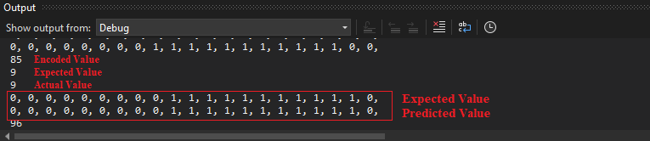

Fig.4.1. Output of Ticket Number

If we choose any other values for N and W for example N=18 and W=3 then it does not match the expected bucket output.

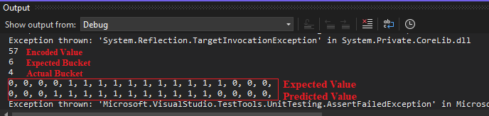

Fig.4.2. Output of Ticket Number

Once all the inputs are encoded, we can call the Bitmap method to create the output in 2D Bitmap format. After setting all the parameter values and executing the program, the output images will be generated by the Bitmap are shown in Fig.4.3

In this tickets number in Music concert test case, there is a several range of ticket numbers mentioned above and we can see the same in the below figure Fig.4.1(Output of Ticket Number for Music Show) which is the snapshot of output of encoded Ticket Number for Music Show case.

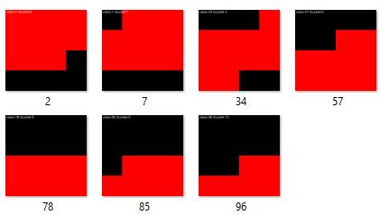

Fig.4.3. Output of Ticket Number

## *Test Case IV: Age of Employees in a Company*

Encoding the different category of employees in Company according to their age. Consider we have teenagers, adults, middle age and senior citizens employees in Company. We must differentiate employees based on this category choosing the bracket of age. Assuming the employees have ages in the range of 0 year to 59 years. We would like to encode differently example 0-18 years as one category and other category such as young adult range 19-39 years, middle age range 35-49, Senior age range 50+ years. So, we are encoding different category age of people in different way.

1. Age of employees is in between 0 to 59 years, Hence the MinVal = 0 and MaxVal = 59.
2. Computing the Range = MaxVal – MinVal which is equal to 59.
3. Hence the number of bits that are set to encode a single value the ‘width’ of output signal ‘W’ used for representation is 3.
4. Total number of bits in the output ‘N’ used for representation is 7.
5. We are choosing the value of N=7 and W=3 to get the desired output which is shown below:



*Fig.5.1. Output of Ticket Number*

1. If we choose any other values for N and W for example N=6 and W=3 then it does not match the expected output which is shown below:



*Fig.5.2. Output of Ticket Number*

Once all the inputs are encoded, we can call the Bitmap method to create the output in 2D Bitmap format. After setting all the parameter values and executing the program, the output images will be generated by the Bitmap are shown in Fig.5.3

In this Age of employees in Company test case, there is a shift within those categories mentioned above and we can see the same in the below figure Fig.9(Output of Age of employees in Company) which is the snapshot of output of encoded Age of employees in Company test case.



*Fig.5.3. Output of Ticket Number*

## *Test Case IV: Temperature Ranges*

This test involves the encoding pf different temperature ranges for daily life routine. Let us say at -10 Celsius, it's quite cold and you'll need warm clothing to stay comfortable. Snow may be on the ground, and icy conditions are possible.

At 0 Celsius, the temperature is freezing point, and water will start to turn into ice. This is the temperature at which ice skating rinks are maintained.

At 10 Celsius, it's starting to warm up a bit and you may be able to get away with a lighter jacket. However, it's still quite chilly outside.

At 20 Celsius, it's a comfortable temperature for most people and you may only need a light sweater or shirt. It's a great temperature for outdoor activities such as hiking or picnicking.

At 30 Celsius, it's starting to get hot and you'll want to wear lightweight, breathable clothing. This is a typical temperature for summer days in many parts of the world. At 40 Celsius, it's very hot and you'll want to stay in air-conditioned environments as much as possible. This is the temperature at which some outdoor activities, such as sports games, may be cancelled due to safety concerns.

At 50 Celsius, it's extremely hot and dangerous. Heatstroke and dehydration are real risks at this temperature.

At 60 Celsius, it's dangerously hot and can cause severe health problems. This is the temperature at which some electronics may start to malfunction due to overheating.

At 70 Celsius, it's approaching boiling point and any liquid exposed to this temperature will evaporate quickly.

At 100 Celsius, it's the boiling point of water and any higher temperature will cause it to turn into steam.

So, we are encoding different ranges of temperature in different way.

1. Temperature ranges is in between -10 to 100 Celsius, Hence the MinVal = -10 and MaxVal = 100.
2. Computing the Range = MaxVal – MinVal which is equal to 110.
3. Hence the number of bits that are set to encode a single value the ‘width’ of output signal ‘W’ used for representation is 11.
4. Total number of bits in the output ‘N’ used for representation is 20.
5. We are choosing the value of N=20 and W=11 to get the desired output which is shown below:

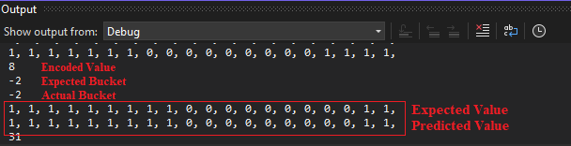

*Fig.6.1. Output of Ticket Number*

1. If we choose any other values for N and W for example N=6 and W=3 then it does not match the expected output which is shown below:

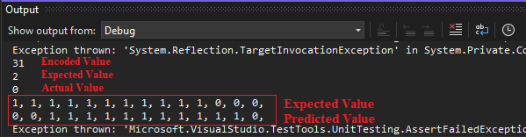

*Fig.6.2. Output of Ticket Number*

Once all the inputs are encoded, we can call the Bitmap method to create the output in 2D Bitmap format. After setting all the parameter values and executing the program, the output images will be generated by the Bitmap are shown in Fig.6.3

which is the snapshot of output of encoded temperature ranges for daily life routine test case.

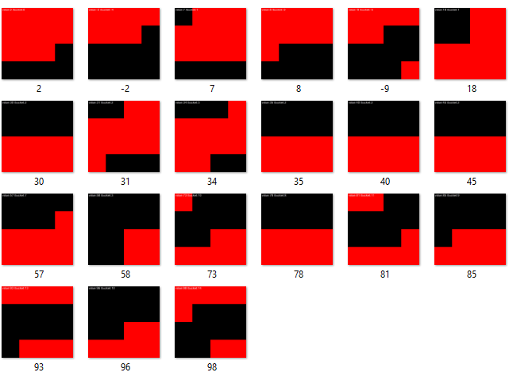

*Fig.6.3. Output of Temperature Ranges*